**Manual Test Plan: DuoDuel Game**

**Overall Goals:**

* Show all bots when “See all bots” button is pressed
* Draw bots button should display a random selection of 5 bots
* Only two bots should be added at one time.
* Bots should duel functionally
* Total functionality upon completion, including win/loss scoreboard accuracy

**Identified Bugs/Fixes:**

* Wins are tabulated as losses on the scoreboard
  + Steps involved in reproducing bug:
    - Navigate to site
    - Press “Draw”
    - Choose two bots and click “add to duo” on each bot
    - Duel bots
    - Check win/loss result
    - Compare result to scoreboard
    - See which score was incremented - wins or losses
  + Expected Result:
    - Wins will increment “wins” on scoreboard
    - Losses will increment “losses” on scoreboard
  + Actual Result:
    - Both wins and losses increment “losses” on scoreboard
  + Testing environment:
    - Chrome v. 110.0.5481.96 (Official Build) (x86_64)
  + Evidence:
  + Fix: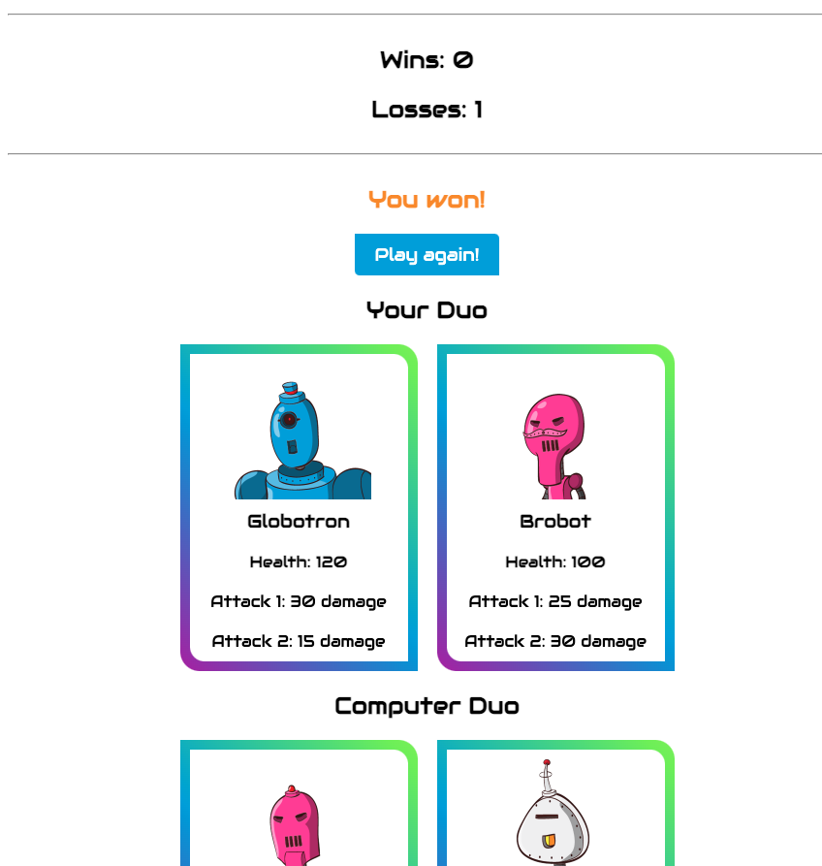
    - Line 81 in “server.js” needs to have ++ incrementation changed from “losses” to “wins.” Works when tested.
* 400 error when clicking “see all” button
  + Steps involved in reproducing bug:
    - Navigate to site
    - Press “See all bots”
    - Receive error
  + Expected result:
    - All bot cards loaded on page
  + Actual result:
    - 400 error
  + Testing environment:
    - Chrome v. 110.0.5481.96 (Official Build) (x86_64)
  + Fix:
    - Identified root cause as an unnamed array “botsArr” in server file, changed to “**bots**” to match the actual array name.